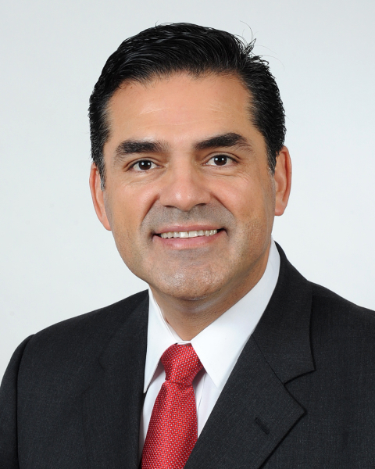
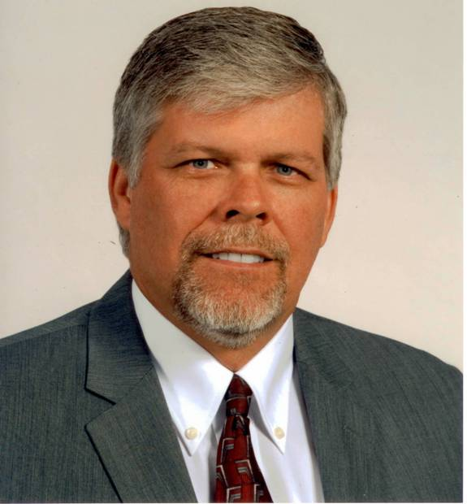
JOHN R. NOGUEZ, Assessor
John R. Noguez became the 26th Assessor of Los Angeles County, following his election in November 2010 with nearly one million votes. Mr. Noguez is the first Assessor of Latino heritage elected to office in 124 years and represents all 10 million residents of Los Angeles County. The Office of the Assessor is responsible for maintaining a property roll of 2.4 million homes and businesses in Los Angeles County with a gross total value of $1.1 trillion dollars in 2011.
Mr. Noguez joined the Assessor's Department 27 years ago as a student worker and rose steadily through the ranks to hold the position of Appraiser Specialist, focusing on major business properties, including banks and shopping centers, as well as historic structures such as the Bradbury Building, and inner city condominium conversions. He later worked as Special Assistant to former Assessors Robert Quon and Rick Auerbach, including serving as their liaison with realtor, homeowner, and community organizations.
The Assessor holds a California State Board of Equalization Advanced Appraisal Certificate and attended Cal State University, Los Angeles, concentrating on real estate studies in the School of Finance.
While pursuing his career in the Assessor's Department, Mr. Noguez also was elected to office in the City of Huntington Park in 2000, where he served a decade as Mayor, Member of the City Council and City Clerk. While serving on city council, he served in several leadership positions that include the President of the League of California Cities, Los Angeles Division, and Secretary/Treasurer of the California Contract Cities Association.
A native of Los Angeles, Assessor Noguez was born at Kaiser Hospital in Hollywood and raised in the multi-cultural Boyle Heights area of Los Angeles.

CAROL W. QUAN
Supervising Special Assistant
Carol Quan was raised in Los Angeles and graduated from the University of California at Los Angeles, with a Bachelor of Arts in Political Science and a Certificate in Business and Administration.
Mrs. Quan has worked for over twenty-six years in the Los Angeles County Assessor’s Office. She began her career in 1986 as a real property appraiser trainee and has risen through the ranks in assignments ranging from property valuations to special investigations. In September 2001, Carol Quan was appointed Special Assistant to then Los Angeles County Assessor Rick Auerbach. She is now Supervising Special Assistant to Los Angeles County Assessor John R. Noguez.
Carol Quan is a member of the International Association of Assessing Officers and was president of that organization’s Los Angeles Chapter in 1994. She currently resides in Montebello with her husband, Mel, and two daughters, Patricia and Madeline.

JERRY E. POWERS, Chief Probation Officer
Jerry E. Powers was born in Stockton, California and grew up in Rio Vista, California. After graduating from Rio Vista High School in 1980, he attended the University of California at San Diego where he received his Bachelor of Arts degree in Psychology in 1985.
Mr. Powers began his Probation career with the San Diego County Probation Department in 1984 as a student worker. During his 15 years with the Department, he moved up the ranks to the level of supervisor. He worked in a multitude of assignments, which included working and supervising in the adult and juvenile institutions, school-based, and community supervision assignments.
In September of 2000, Mr. Powers returned to California’s Central Valley as the Superintendent of the juvenile hall for Stanislaus County Probation Department. Shortly thereafter, he was promoted to Deputy Chief, and in November 2002, he was appointed by the Court as Stanislaus County’s 13th Chief Probation Officer where he spent 10 years leading the Department. During his tenure as Chief, he spent a significant amount of time working with State policy makers advocating for probation and corrections reform. He provided expertise to the Legislature and policy makers on criminal justice system improvements, as well as to California State and Federal courts.
On December 6, 2011, Chief Powers became the 19th Chief Probation Officer for the Los Angeles County Probation Department—the largest probation services agency in the United States with over 6,200 employees. 4,400 of those employees are sworn peace officers that supervise over 80,000 adults and juveniles on probation in the Los Angeles County with an annual budget of over $700 million.
The newest of the many projects that Chief Powers has been tasked with is to oversee and implement California’s new Prison Realignment Plan (Assembly Bill 109). Under this new plan, the Los Angeles County Probation Department is tasked with supervising nearly 10,000 non-serious, non-violent, non-sex offender parolees (The term parolee is replaced with the new term “Post-released Community Supervision”).
When the Chief is not working at the Probation Headquarters in Downey, he enjoys spending time with his wife and his three children. His hobbies include golfing, hunting, fishing, diving, and traveling.

GEORGE G. YAN
Probation Director
With over 37 years of service to the Los Angeles County Probation Department, Mr. Yan has worked in various assignments throughout the Department such as the juvenile halls, probation camps, special programs, Juvenile Alternative Work Service (JAWS), Asian Gang Unit, Gang Alternative and Prevention Program, Staff Training, and the Eastlake Intake and Detention Control Unit. He is currently assigned to Central Juvenile Hall as a Probation Director.
In 1999, Mr. Yan developed and established the Probation Training Academy at West Los Angeles College through a revenue sharing partnership. It provided the largest probation department in the nation with a dedicated professional training site. The Academy was also the impetus for bringing about uniforms to our institutional officers and professionalizing the image of the Department as a whole.
His credentials include a Bachelor's degree in Sociology with a minor in Physical Education. He holds the academic rank of Professor of Administration of Justice at West Los Angeles College, certificates in Peace Officer Standards and Training (POST), Standards and Training for Corrections (STC), Use of Chemical Agents, Basic Physical Restraint, and the Community Emergency Response Team (CERT).
He is actively involved in the Asian community and with Asian organizations. He was the former 1st VP of the Asian Pacific Probation Association (APPA), and is currently the Vice-President of Events and Programs for the Los Angeles County Asian American Employees Association (LACAAEA).

